***Assignment Name****:* ***Lab12:*** *(****Arrays 2-dim)***

***Due date:******12/7/2022, by 11:00 am.***

***Grade for assignment: 30*** *points*

***Purpose:*** *Obtain experience in using Arrays. Assignment accomplishes course learning objective “Understand, create, and apply simple data types and arrays.” Assignment also provides preparation for COSC236 course, and enhances skills needed in Information Technology (IT) and Computer Science industries.*

***Skills:*** *Purpose of assignment is to help you practice the following skills.*

*-Creating 2-dimentional Arrays*

*-Assign values to 2-dimentional Array elements*

***Knowledge:*** *Become familiar with how to use structured data types in computer programs.*

***\*\*\*\*\*\*\*\*\*\*\*\*\*\*\*\*\*\*\*\*\*\*\*\*\*\*\*\*\*\*\*\*\*\*\*\*\*\*\*\*\*\*\*\*\*\*\*\*\*\*\*\*\*\*\*\*\*\*\*\*\*\*\*\*\*\*\*\*\*\*\*\*\*\*\*\****

***Place your Name(s) below:***

***Pairs work:*** *Please work in pairs.* ***One student in team should submit work****. Put* ***your first and last name on the assignment*** *and* ***your partner’s first and last name on the*** *assignment*

***Note(s):***

1. *All programs should be completed within the Visual Studio Code environment. There are guides in blackboard to start you off with Visual Studio Code.*

***Partner 1: Name Blessing Abumere***

***role (did the typing or read and review) _____________________________***

***Partner 2: Name ______________________________________________***

***role (did the typing or read and review)______________________________***

***Please note if one partner did not work on all problems.***

***Submission instructions:*** *All submissions will be done using blackboard.* ***Answers are to be submitted in a Microsoft word document.***

***Task****:*

***Examples:*** *Refer to your notes from class, the Arrays (Part1) PowerPoint, Arrays (Part2) PowerPoint, in class exercises and any available videos (located in Blackboard).*

***Part1 (30 points):***

1. *Type in the following program. Add a comment at the top to include your name(s) and the date.*

#include <iostream>

using namespace std;

int main()

{

char TicTacTow[3][3];

int row;

int col;

for (row = 0; row < 3; row++)

{

for (col = 0; col < 3; col++)

TicTacTow[row][col] = '?';

}

//2nd: Assign X to the Frist row and column

//3rd: Assign O to the Last row and column

//1st: Print the array in table form

int r;

int c;

for (r = 0; r < 3; r++)

{

for (c = 0; c < 3; c++)

cout << TicTacTow[r][c] << " ";

cout << endl;

}

return 0;

}

***Add*** *the following steps below to the original code above,* ***DO NOT r****emove the original code from your program.*

1. *Underneath the comment:// 2nd: Assign X to the First row and column;* ***Add code*** *to assign the letter X to first row and column.*
2. *Underneath the comment:// 3rd: Assign O to the Last row and column;* ***Add code*** *to assign the letter O to last row and column.*
3. ***SUBMIT your modified code, and sample of output (Below):***
4. /*
5. Blessing Abumere
6. COSC 175
7. 11/30/2022
8. */
9. #include <iostream>
10. using namespace std;
11. int main()
12. {
13. char TicTacTow[3][3];
14. int  row;
15. int  col;
16. for (row = 0; row < 3; row++)
17. {
18. for (col = 0; col < 3; col++)
19. TicTacTow[row][col] = '?';
20. }
21. //2nd: Assign X to the First row and column
22. TicTacTow[0][0] = 'X';
24. //3rd: Assign O to the Last row and column
25. TicTacTow[2][2] = 'O';
27. //1st: Print the array in table form
28. int r;
29. int c;
30. for (r = 0; r < 3; r++)
31. {
32. for (c = 0; c < 3; c++)
33. cout << TicTacTow[r][c] << " ";
34. cout << endl;
35. }
37. return 0;
38. }

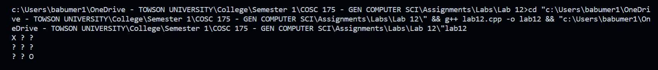

***\*\*\*\*\*\*\*\*\*\*\*\*\*\*\*\*\*\*\*\*\*\*\*\*\*\*\*\*\*\*\*\*\*\*\*\*\*\*\*\*\*\*\*\*\*\*\*\*\*\*\*\*\*\*\*\*\*\*\*\*\*\*\*\*\*\*\*\*\*\*\*\*\*\*\*\*\****

***Criteria for Success****:*

***a****) Be sure to submit your code and output above for each question;* ***Submission of Code and output is required****. (Note: use screen shots or copy and paste).*

*For example if the assignment was to write a program that displays “Hello World”*

*Your* ***code*** *would be as follows:*

*//Lab1 answer COSC175002*

*#include <iostream>*

*using namespace std;*

*int main()*

*{*

*cout << "Hello, world" << endl;*

*system("pause");*

*} // end of main*

*Your* ***output*** *would be as follows:*

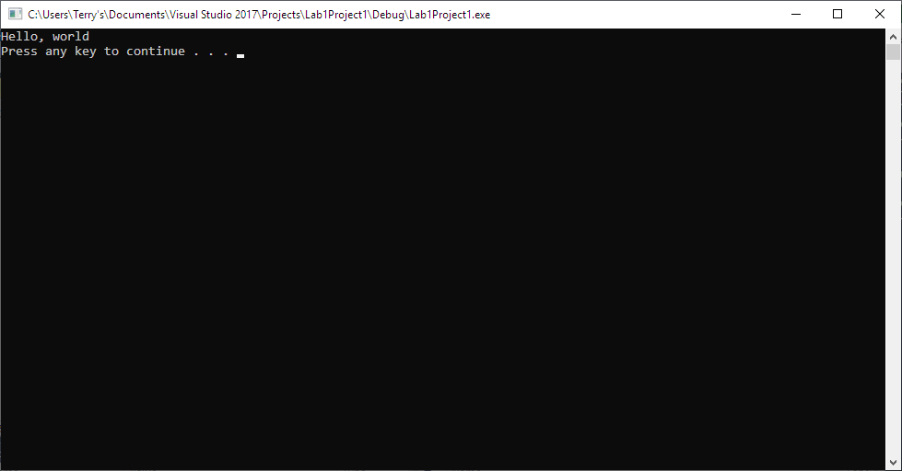

*Note: To avoid additional point deductions; remember to submit both code and output.*

***b) Late policy:*** *Late submissions will receive a zero grade. Get help during the week so that you can submit on time.*